Task Productivity: Verify Tasks — Duration Distribution
Histogram analysis of duration (minutes). Automated tasks: ceil(task_ended - task_started) to 1 sec, then /60. Manual tasks: logic_adjusted_new_step_duration_minutes. Cuts: task, wh_name, task_mode (Automated=BeyondRx email, Manual=otherwise), task_mode × task.

Duration Bins by Task × Task Method
Bins: Less than 1 sec, 1-10 sec, 11-20 sec, 21-30 sec, 31-60 sec, 1-2 min, 2-3 min, 3-4 min, 4-5 min, 5+ min.

Automated — 06 Preverify
Duration bin | Count | %
Less than 1 sec | 1040 | 100.0
1-10 sec | 0 | 0.0
11-20 sec | 0 | 0.0
21-30 sec | 0 | 0.0
31-60 sec | 0 | 0.0
1-2 min | 0 | 0.0
2-3 min | 0 | 0.0
3-4 min | 0 | 0.0
4-5 min | 0 | 0.0
5+ min | 0 | 0.0

Manual — 06 Preverify
Duration bin | Count | %
Less than 1 sec | 120156 | 18.5
1-10 sec | 369972 | 56.9
11-20 sec | 70296 | 10.8
21-30 sec | 27263 | 4.2
31-60 sec | 32759 | 5.0
1-2 min | 17992 | 2.8
2-3 min | 5468 | 0.8
3-4 min | 2406 | 0.4
4-5 min | 1417 | 0.2
5+ min | 2134 | 0.3

Automated — 10 Pending Verify
Duration bin | Count | %
Less than 1 sec | 101 | 100.0
1-10 sec | 0 | 0.0
11-20 sec | 0 | 0.0
21-30 sec | 0 | 0.0
31-60 sec | 0 | 0.0
1-2 min | 0 | 0.0
2-3 min | 0 | 0.0
3-4 min | 0 | 0.0
4-5 min | 0 | 0.0
5+ min | 0 | 0.0

Manual — 10 Pending Verify
Duration bin | Count | %
Less than 1 sec | 784 | 0.1
1-10 sec | 646263 | 76.9
11-20 sec | 125589 | 14.9
21-30 sec | 30908 | 3.7
31-60 sec | 22400 | 2.7
1-2 min | 8803 | 1.0
2-3 min | 2602 | 0.3
3-4 min | 1163 | 0.1
4-5 min | 573 | 0.1
5+ min | 1127 | 0.1

Summary Statistics by Cut
n = count of observations; mean_min, median_min, p25, p75, p90 in minutes. bimodal = True if distribution appears bimodal. Note: Automated tasks (beyondRx email) often have duration=0 and are excluded from duration stats; they appear with n only.
cut | dimension | value | n | mean_min | median_min | p25 | p75 | p90 | bimodal
Overall | — | — | 1491216 | 0.2 | 0.1 | 0.05 | 0.17 | 0.35 | True
task | task | 06 Preverify | 650903 | 0.23 | 0.07 | 0.03 | 0.17 | 0.48 | True
task | task | 10 Pending Verify | 840313 | 0.18 | 0.1 | 0.07 | 0.17 | 0.3 | True
task_mode | task_mode | Automated | 1141 | 0.02 | 0.02 | 0.02 | 0.02 | 0.02 | False
task_mode | task_mode | Manual | 1490075 | 0.2 | 0.1 | 0.05 | 0.17 | 0.35 | True
wh_name | wh_name | OH | 537837 | 0.19 | 0.08 | 0.05 | 0.17 | 0.35 | True
wh_name | wh_name | AZ | 953379 | 0.21 | 0.1 | 0.05 | 0.17 | 0.37 | True
task_mode × task | mode_task | Automated - 10 Pending Verify | 101 | 0.02 | 0.02 | 0.02 | 0.02 | 0.02 | False
task_mode × task | mode_task | Automated - 06 Preverify | 1040 | 0.02 | 0.02 | 0.02 | 0.02 | 0.02 | False
task_mode × task | mode_task | Manual - 10 Pending Verify | 840212 | 0.18 | 0.1 | 0.07 | 0.17 | 0.3 | True
task_mode × task | mode_task | Manual - 06 Preverify | 649863 | 0.23 | 0.07 | 0.03 | 0.17 | 0.48 | True
task × wh_name | task_wh | 10 Pending Verify | AZ | 642861 | 0.19 | 0.1 | 0.07 | 0.17 | 0.3 | True
task × wh_name | task_wh | 06 Preverify | OH | 340385 | 0.21 | 0.07 | 0.03 | 0.17 | 0.42 | True
task × wh_name | task_wh | 06 Preverify | AZ | 310518 | 0.25 | 0.07 | 0.03 | 0.17 | 0.57 | True
task × wh_name | task_wh | 10 Pending Verify | OH | 197452 | 0.16 | 0.1 | 0.07 | 0.17 | 0.3 | True

Visualizations

Verify Topline Counts By Task Method Warehouse
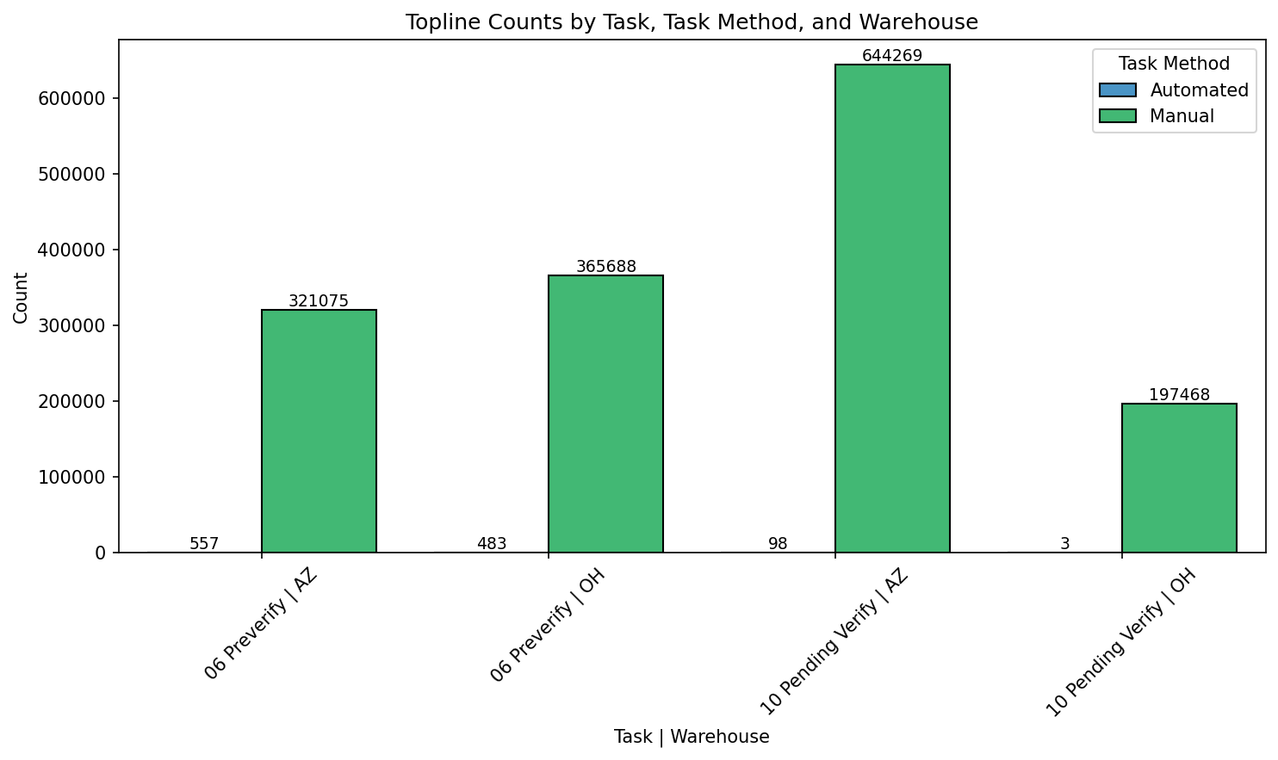

Verify Histogram Overall
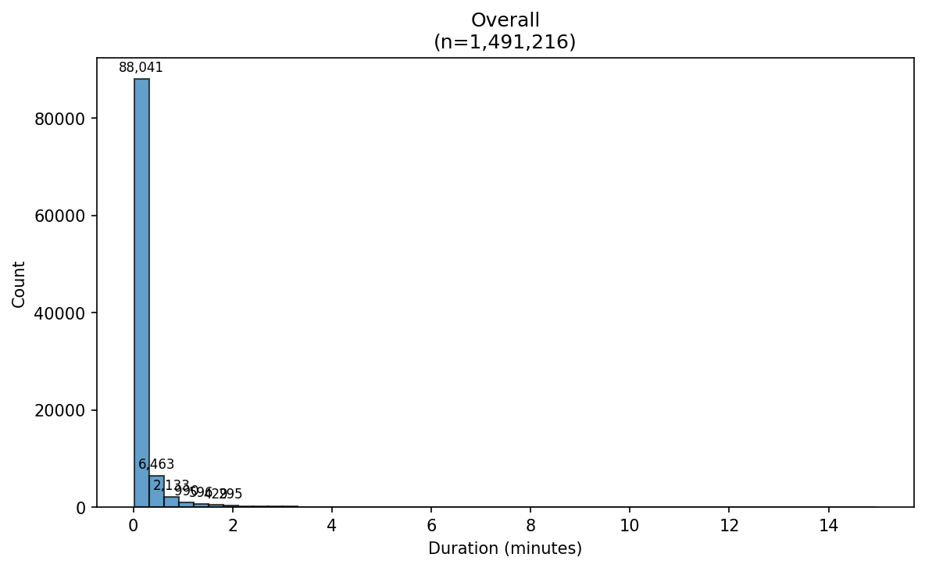

Verify Histogram Mode Task Automated - 06 Preverify
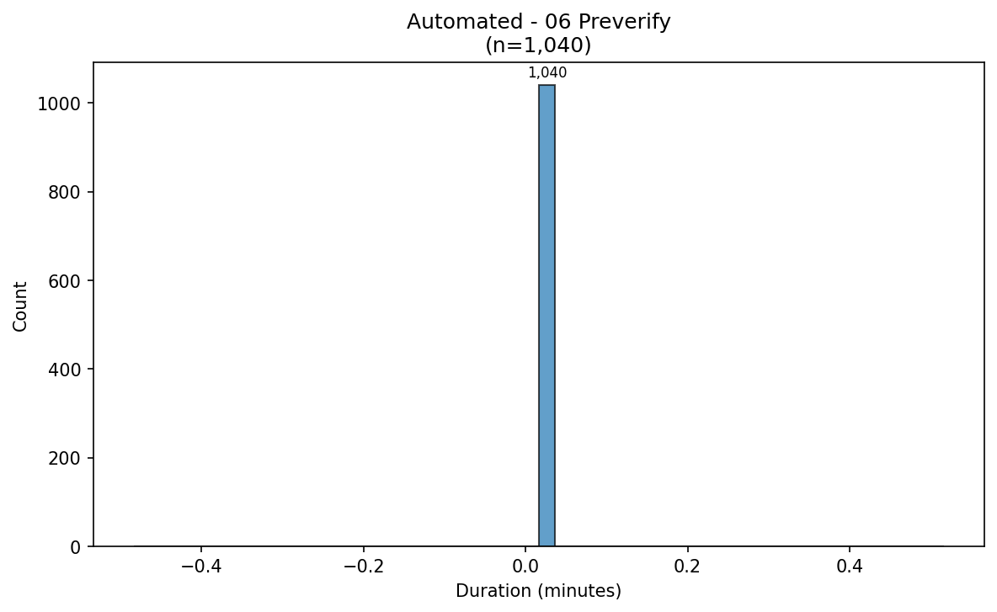

Verify Histogram Mode Task Automated - 10 Pending Verify
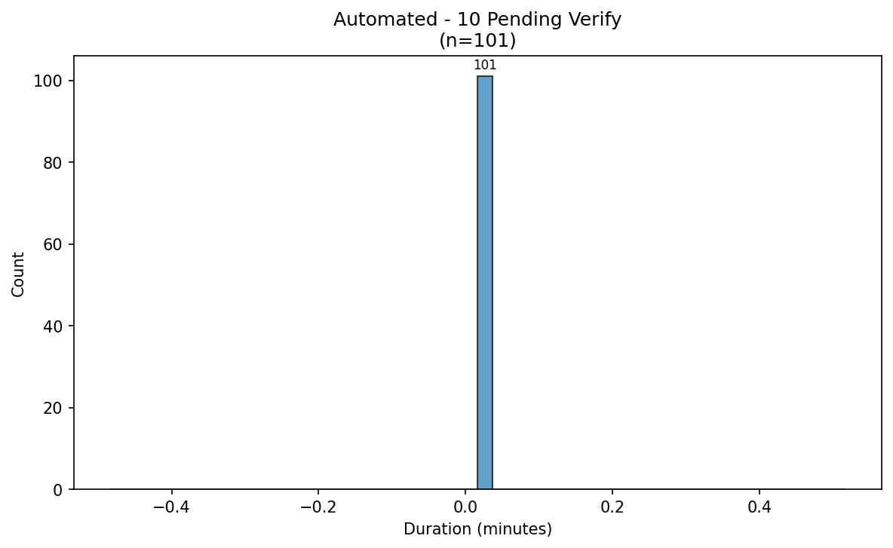

Verify Histogram Mode Task Manual - 06 Preverify
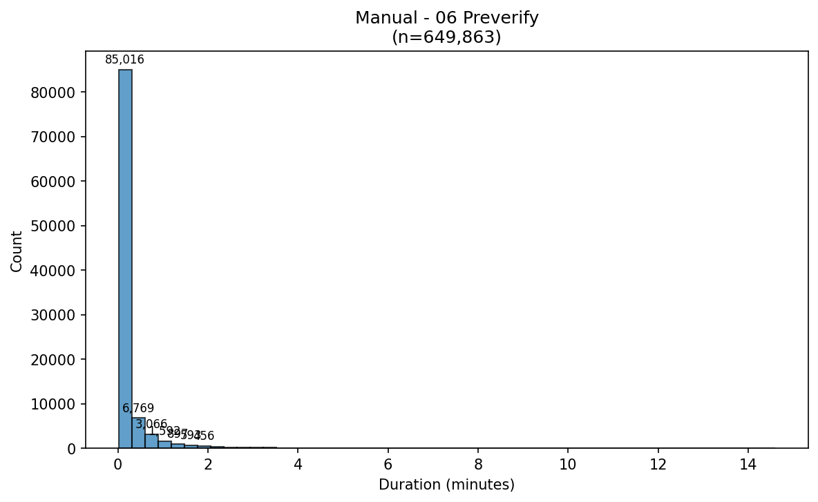

Verify Histogram Mode Task Manual - 10 Pending Verify
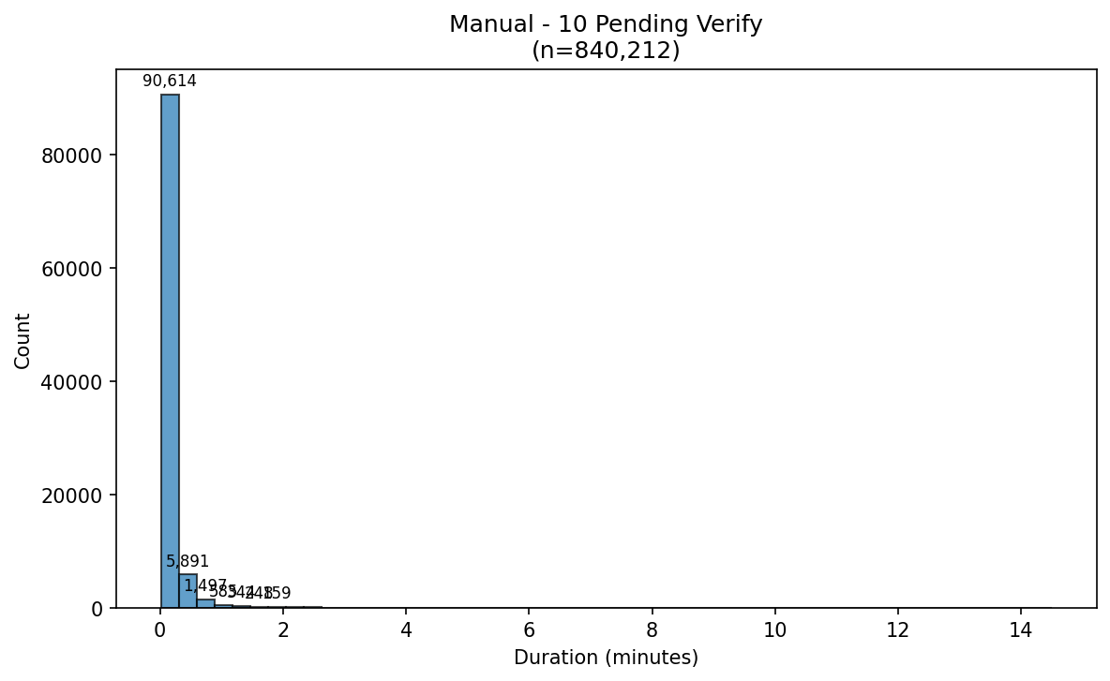

Verify Histogram Task 06 Preverify
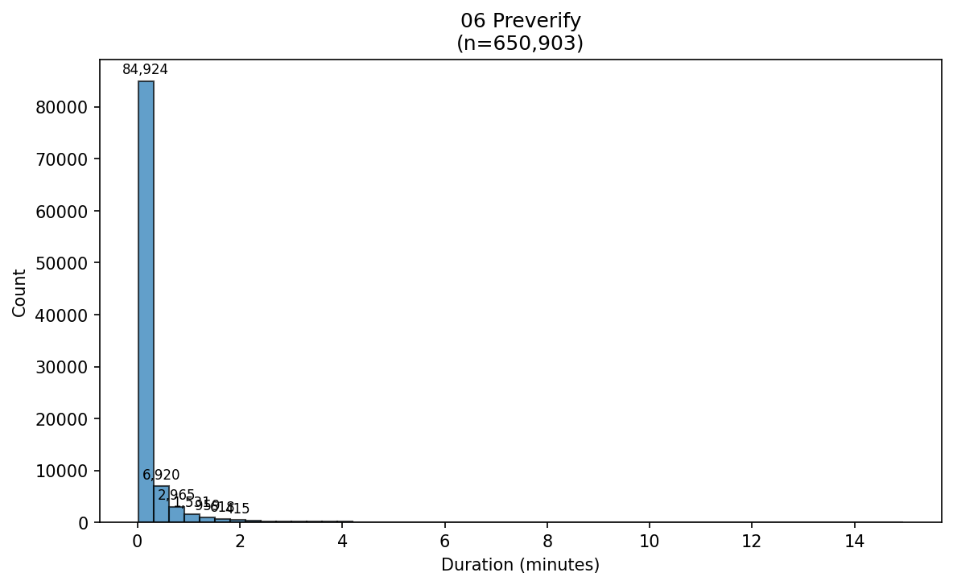

Verify Histogram Task 10 Pending Verify
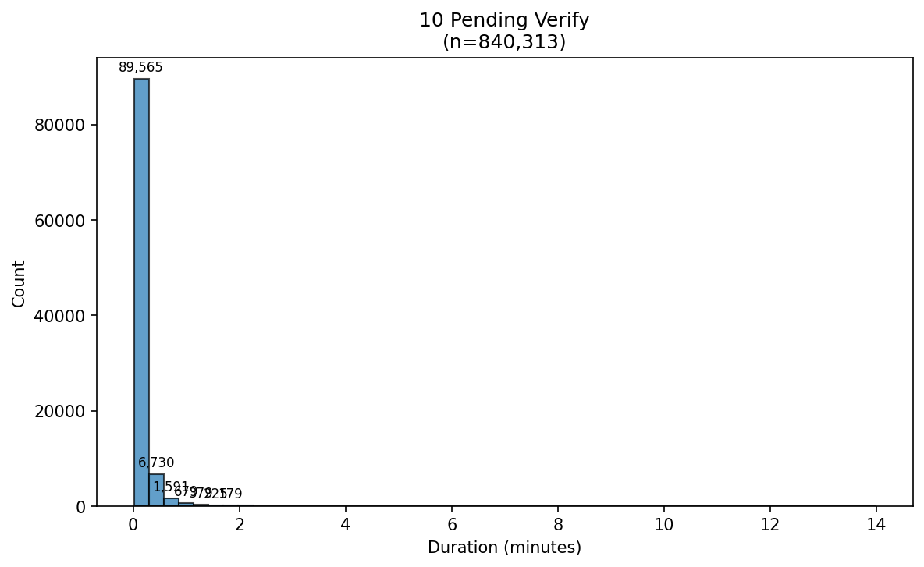

Verify Histogram Task Mode Automated
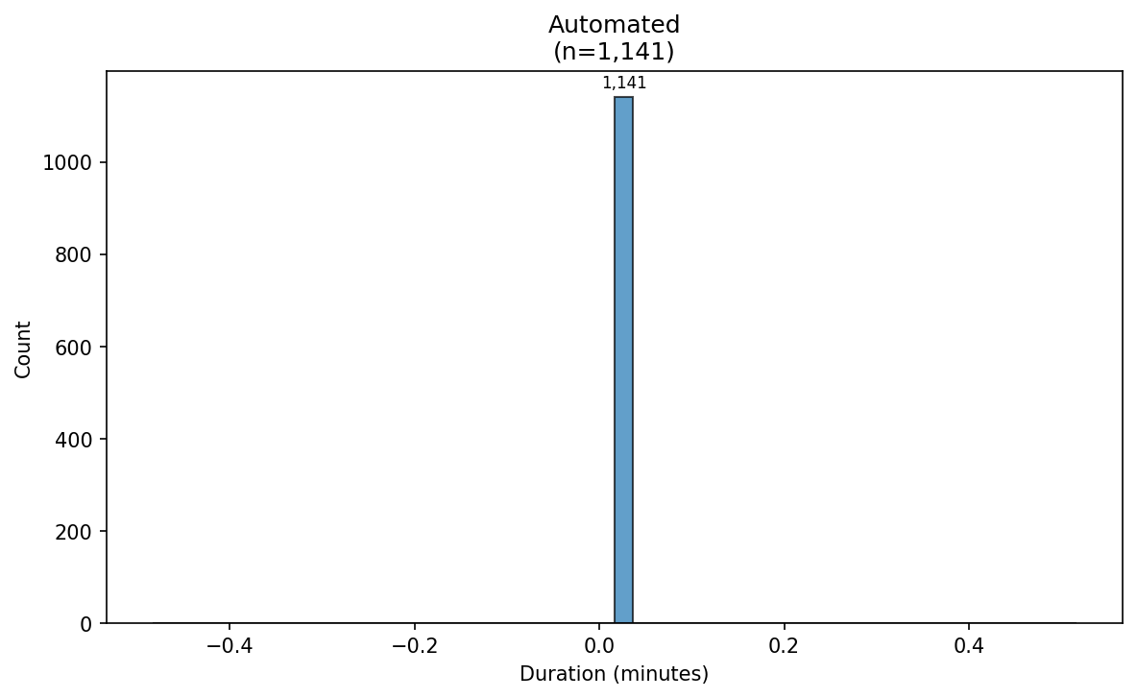

Verify Histogram Task Mode Manual
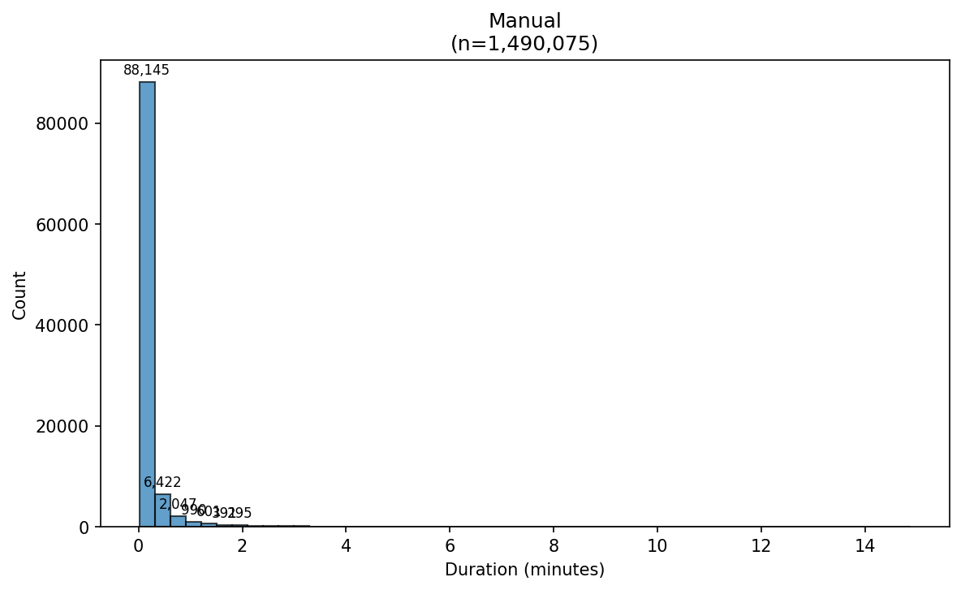

Verify Histogram Task Wh 06 Preverify Az
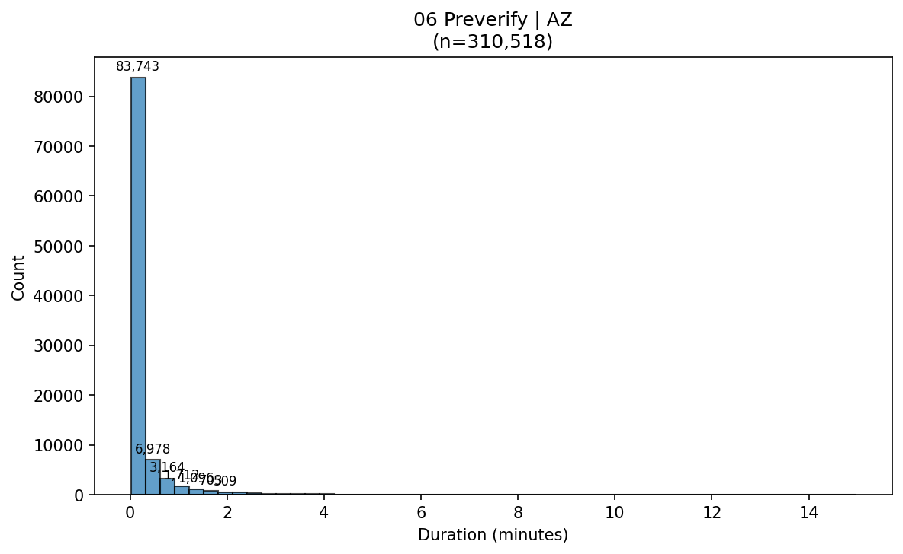

Verify Histogram Task Wh 06 Preverify Oh
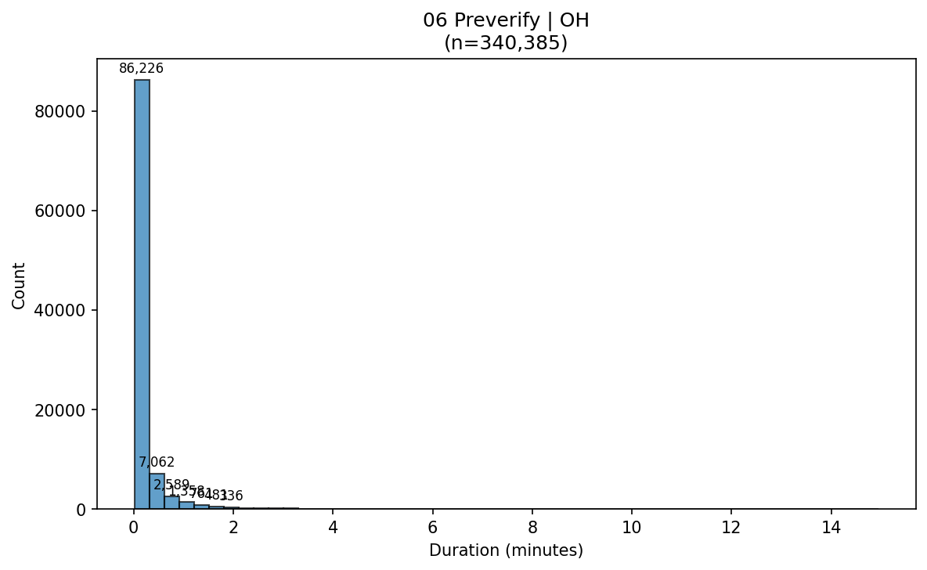

Verify Histogram Task Wh 10 Pending Verify Az
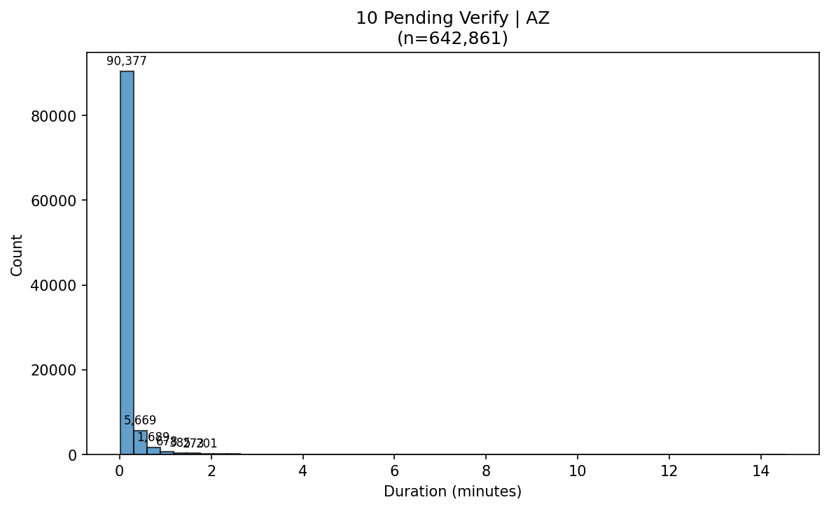

Verify Histogram Task Wh 10 Pending Verify Oh
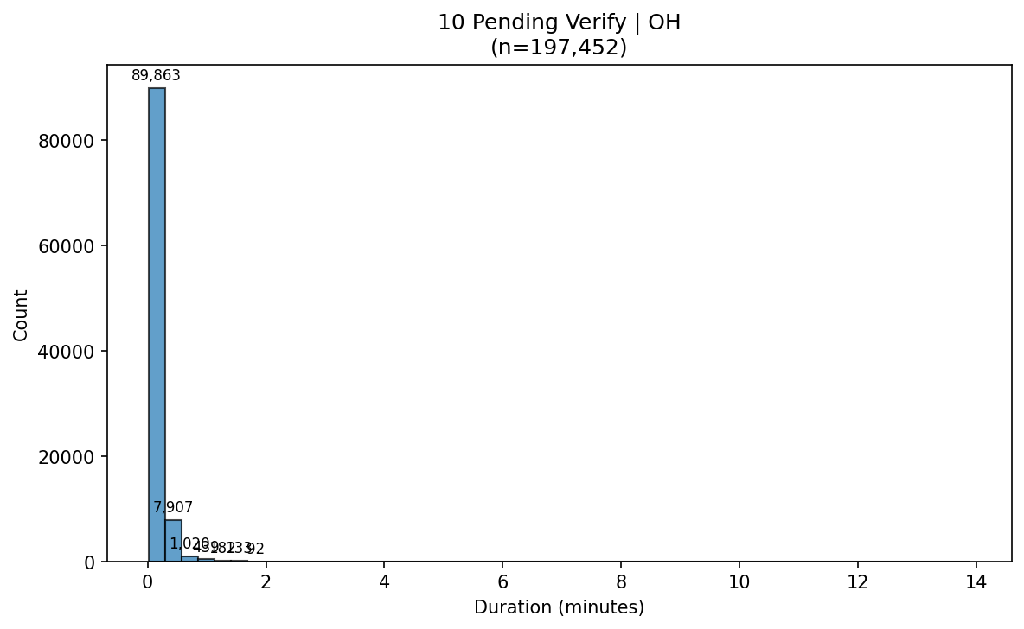

Verify Histogram Wh Az
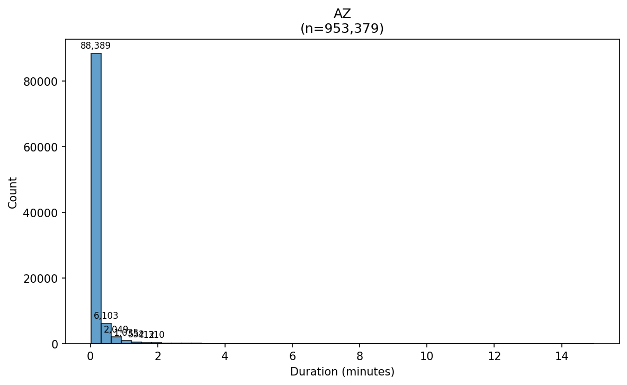

Verify Histogram Wh Oh
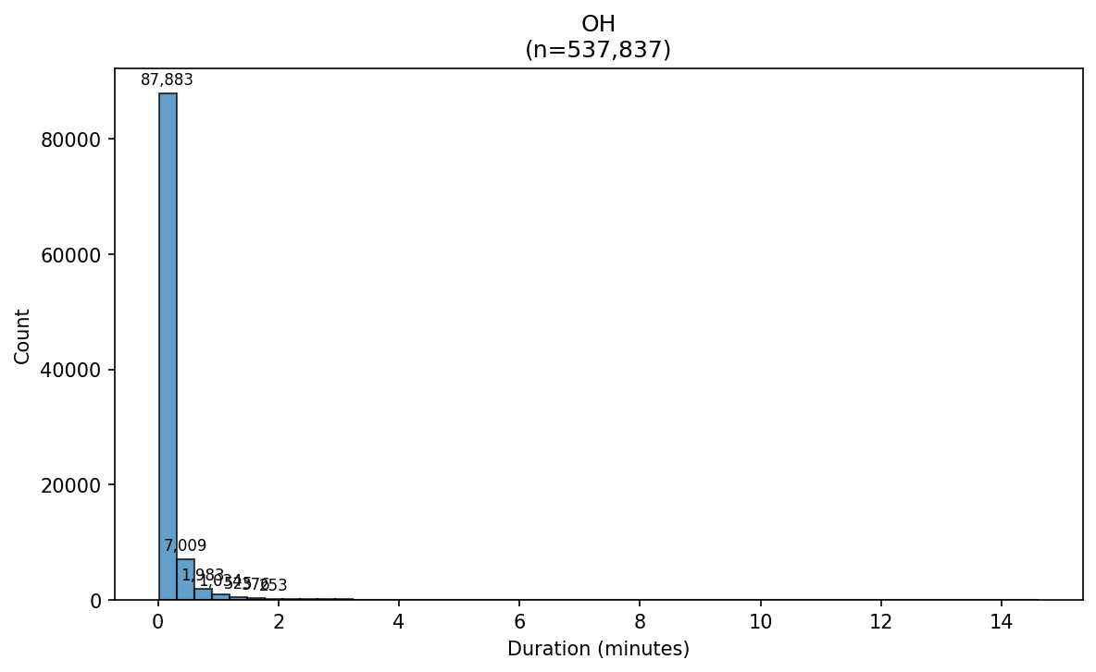

Verify Kde Overall
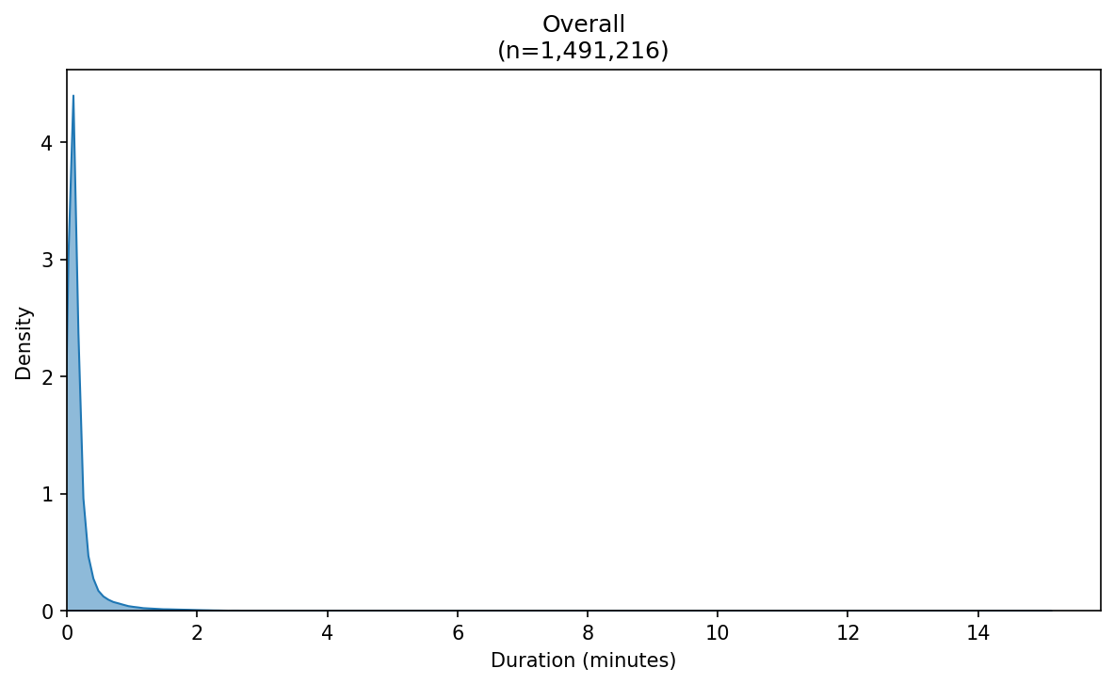

Verify Kde Mode Task Automated - 06 Preverify
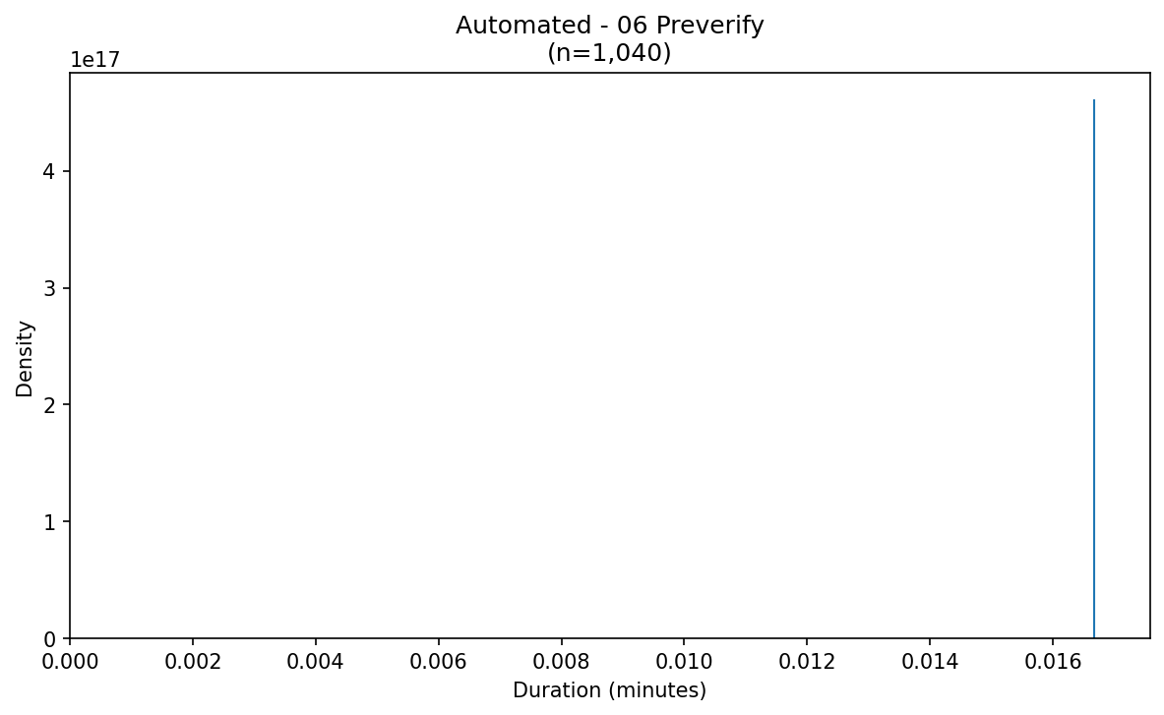

Verify Kde Mode Task Automated - 10 Pending Verify
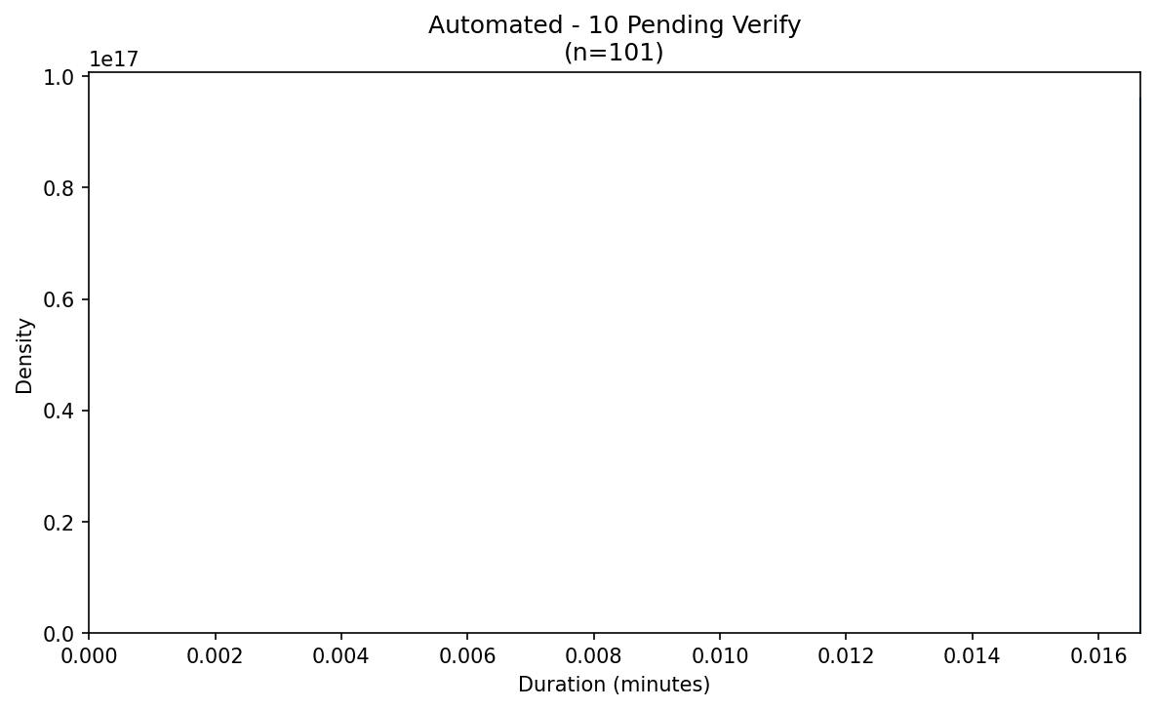

Verify Kde Mode Task Manual - 06 Preverify
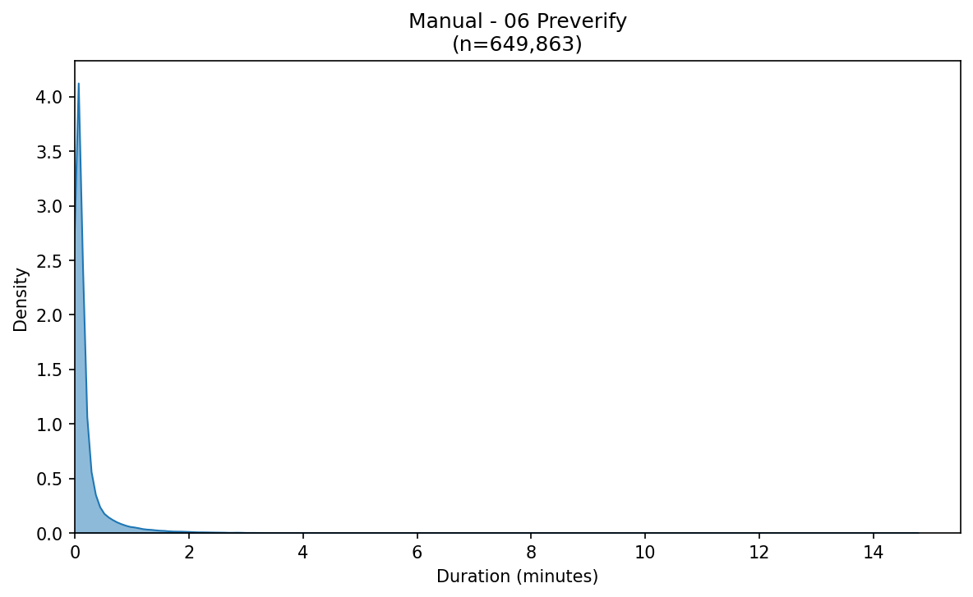

Verify Kde Mode Task Manual - 10 Pending Verify
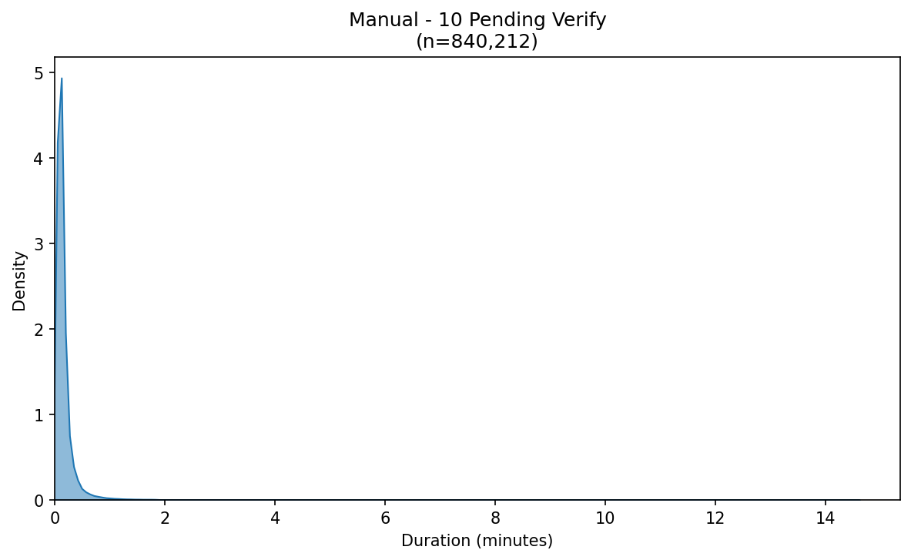

Verify Kde Task 06 Preverify
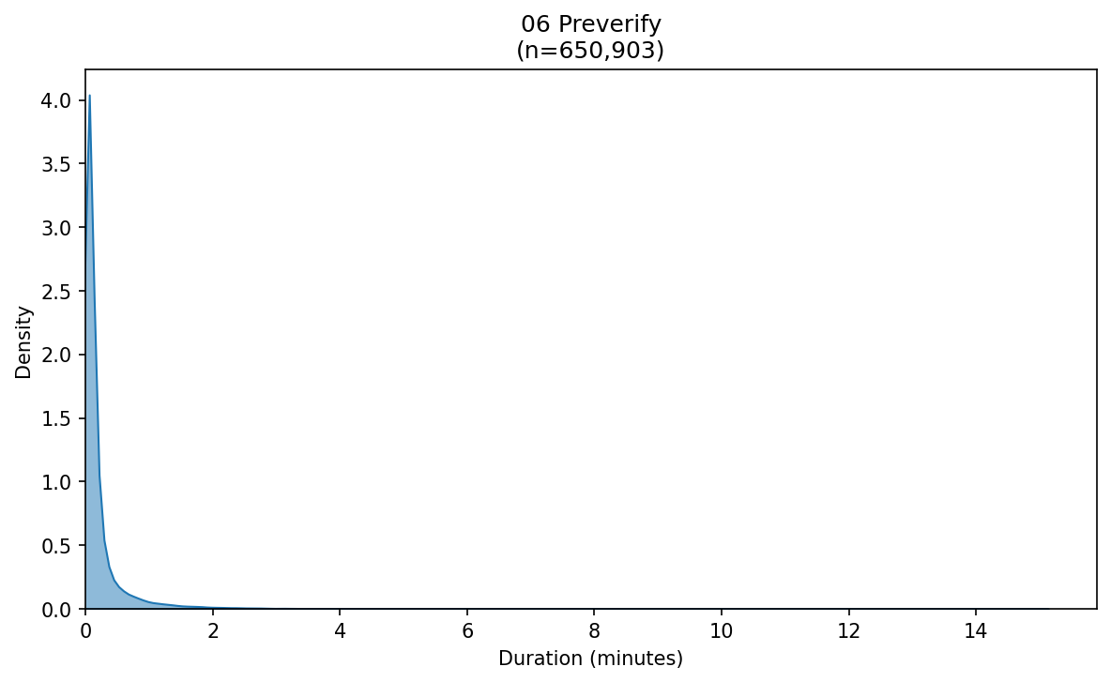

Verify Kde Task 10 Pending Verify
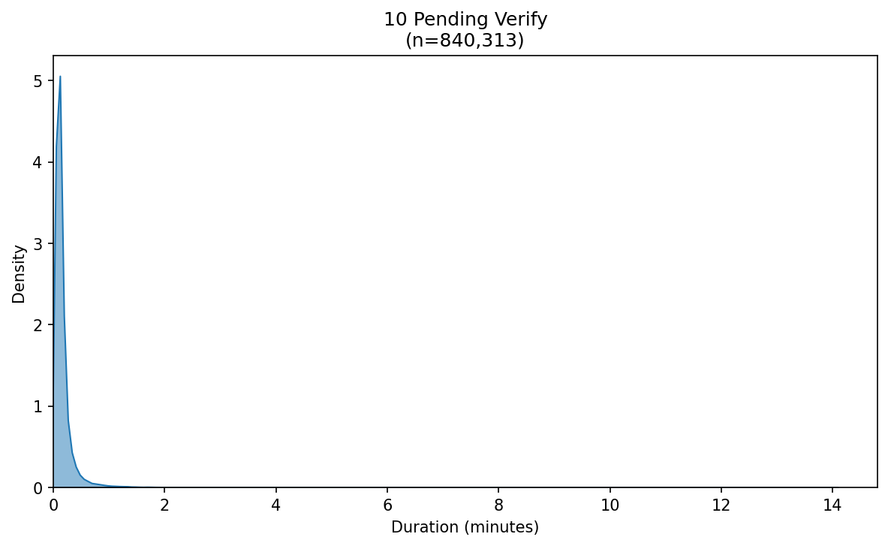

Verify Kde Task Mode Automated
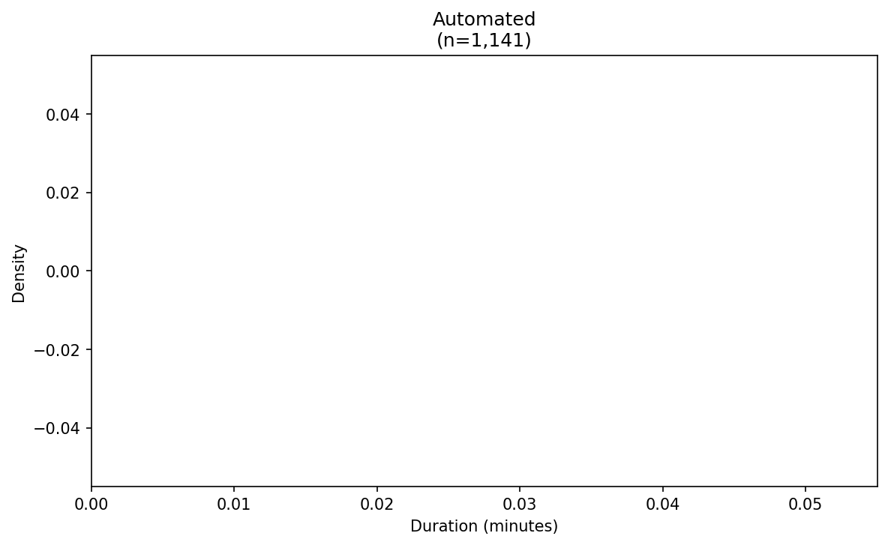

Verify Kde Task Mode Manual
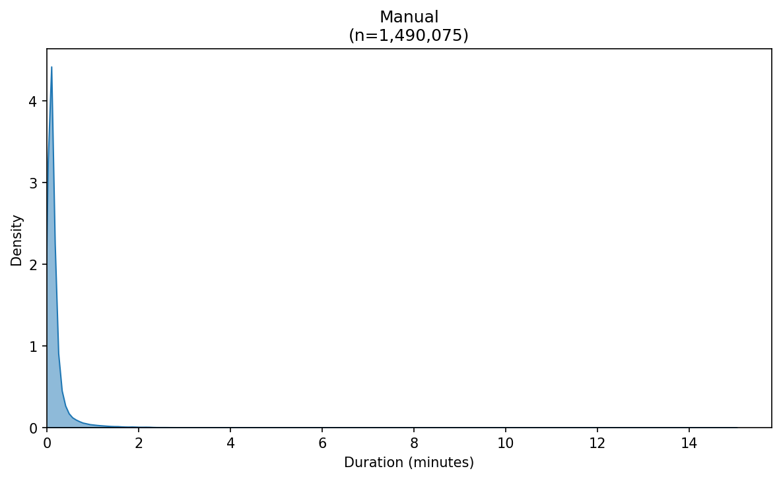

Verify Kde Task Wh 06 Preverify Az
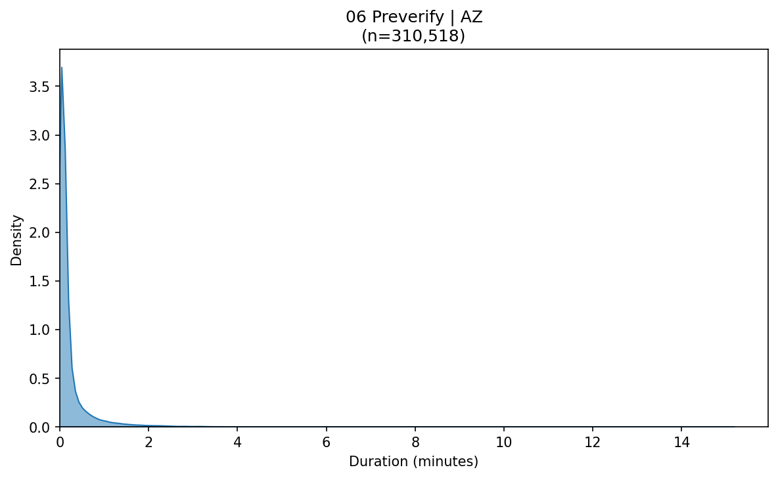

Verify Kde Task Wh 06 Preverify Oh
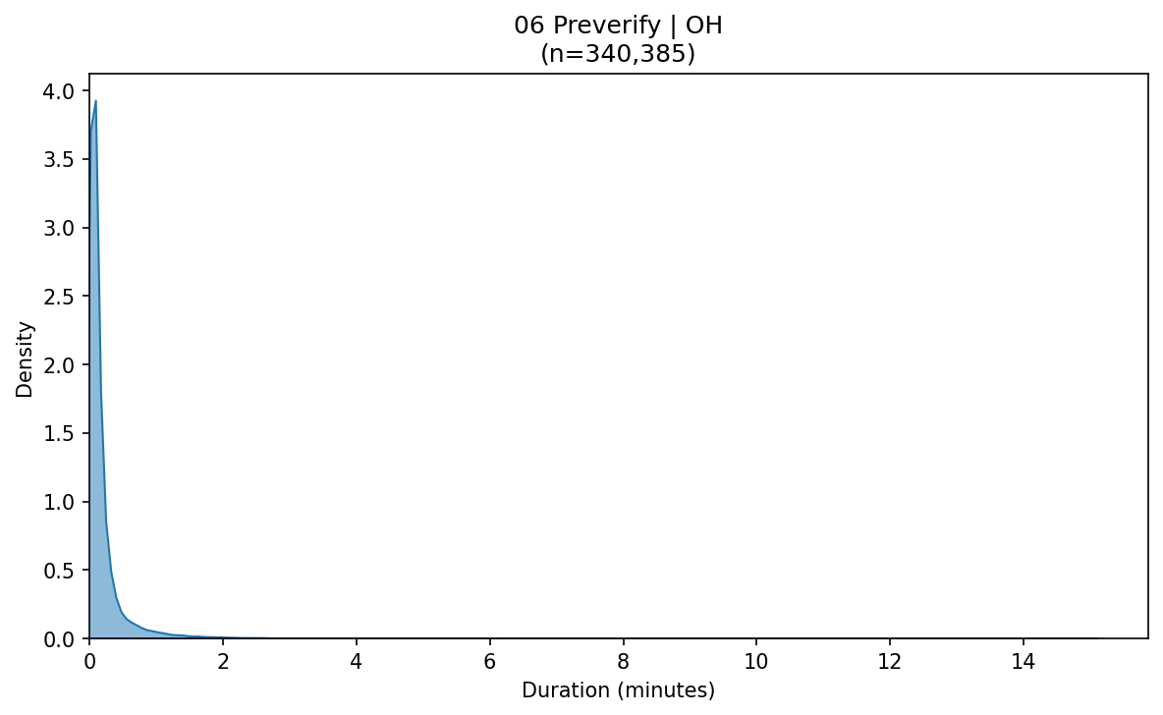

Verify Kde Task Wh 10 Pending Verify Az
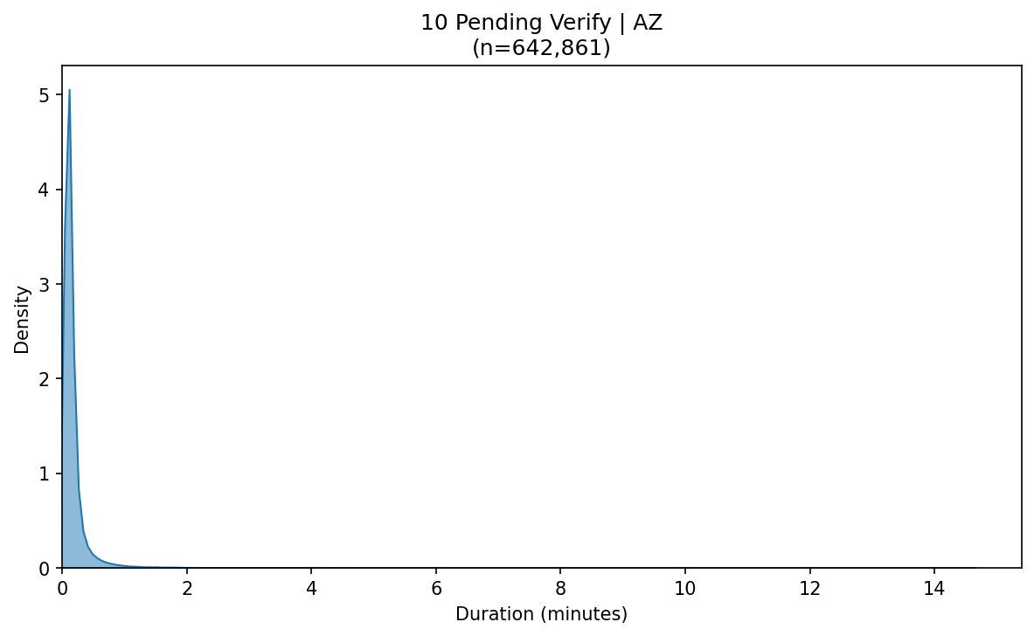

Verify Kde Task Wh 10 Pending Verify Oh
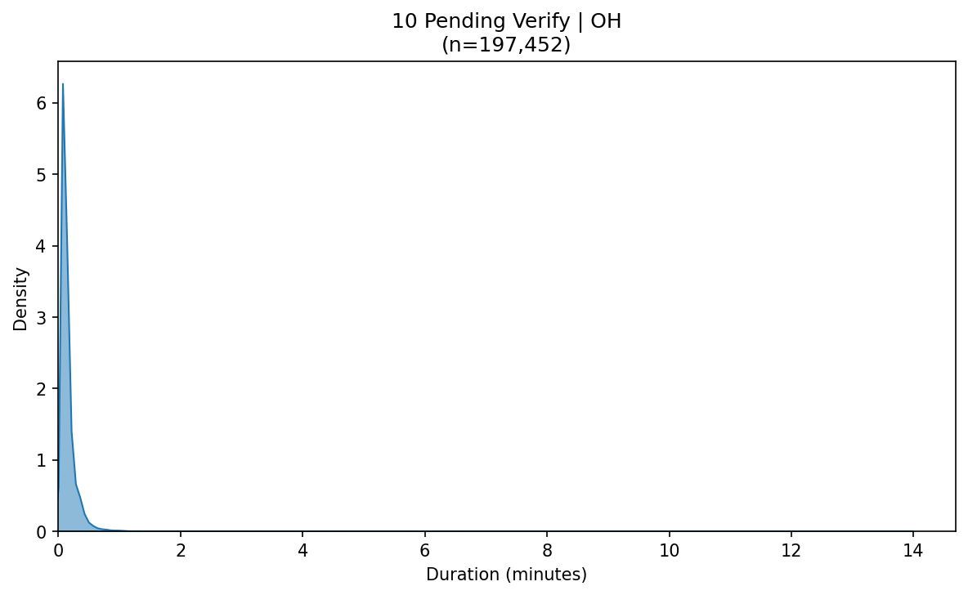

Verify Kde Wh Az
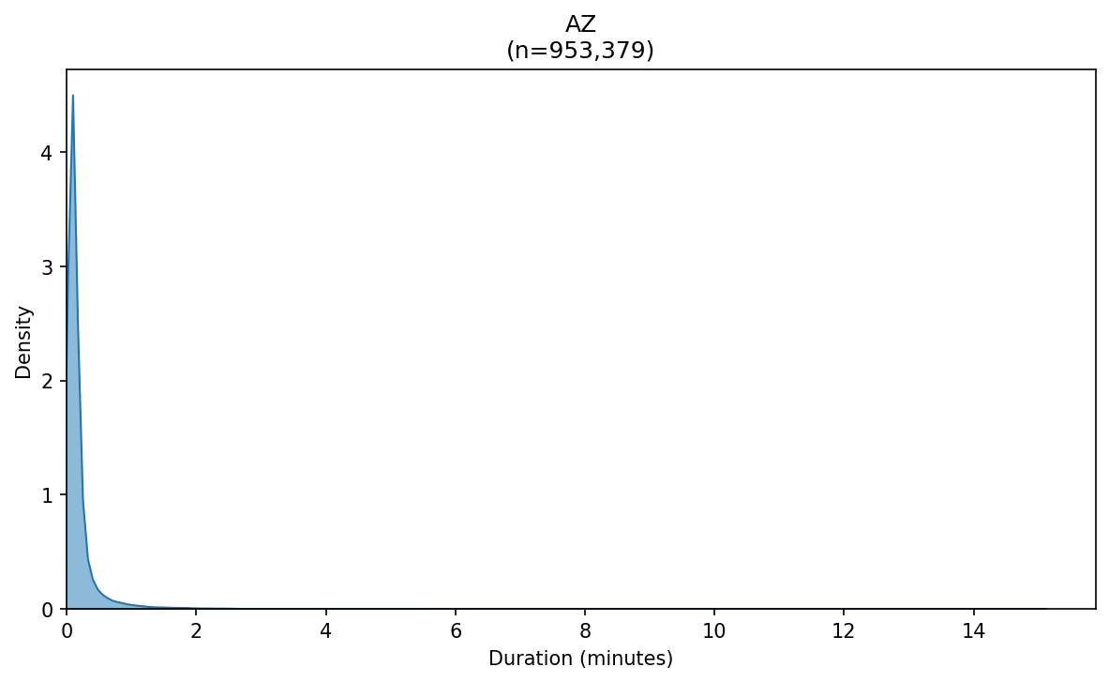

Verify Kde Wh Oh
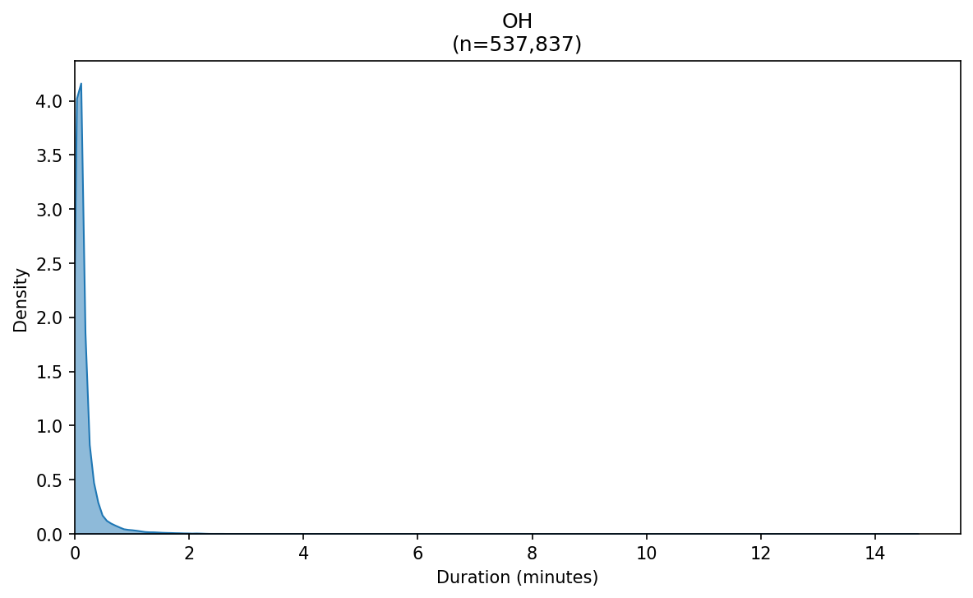

Verify Manual First Minute Breakdown
